ACON is Australia’s largest health organisation  specialising in community health, inclusion and  HIV responses for people of diverse sexualities  and genders. | 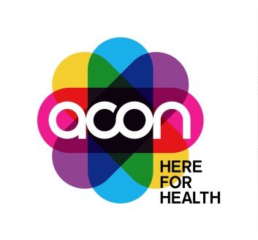

Digital Engagement Officer – Multicultural Engagement & Community Development
This is a great opportunity for a person with digital engagement skills and a passion for supporting multicultural LGBTQ communities looking for a flexible position in a small team in the community health sector.
- Part-time 8-month position, 2 days (14 hours) per week, Surry Hills Sydney.
- Work to improve the health and wellbeing of LGBTQ people from culturally, linguistically and ethnically diverse, migrant and refugee backgrounds, and LGBTQ people of colour.
- Apply your digital engagement skills to train and support the next multicultural LGBTQ community leaders.

The Role
We are looking for an enthusiastic Digital Engagement Officer who is passionate about applying their digital skills to support multicultural LGBTQ communities and groups. This position will support the development, delivery and evaluation of an exciting training program for multicultural LGBTQ community leaders to develop their digital engagement skills to grow and connect their communities, run engaging online events, and promote resilience strategies to racism.
Key to the success of this role is the ability to connect and empower LGBTQ people from culturally, linguistically and ethnically diverse, migrant and refugee backgrounds, and LGBTQ people of colour.

The Multicultural Engagement and Community Development Team:
ACON’s Multicultural Engagement and Community Development Team is responsible for implementing the deliverables outlined in ACON’s Multicultural Engagement Plan to increase health equity, health outcomes, inclusion and leadership opportunities for LGBTQ people from culturally, linguistically and ethnically diverse, migrant and refugee backgrounds, and LGBTQ people of colour.

The role’s responsibilities:
- Support the development, implementation and evaluation of a digital training program for LGBTQ people from culturally, linguistically and ethnically diverse, migrant and refugee backgrounds, and LGBTQ people of colour.
- Plan, schedule, deliver and evaluate community development and health promotion activities, programs, events and resources to achieve established goals and objectives in line with ACON’s Strategy.
- Continually build and enhance partnerships with LGBTQ people and communities from culturally, linguistically and ethnically diverse, migrant and refugee backgrounds, and LGBTQ people of colour.

Salary:
$72,008 per annum pro rata, total remuneration package which includes superannuation and leave loading.
You may also elect to salary package a portion of your salary (up to $30,000 gross-up value) tax-free.

Location:
This position is located at the ACON Sydney Surry Hills Office.
All applications must include:
- a completed ACON application form;
- a document addressing BOTH the essential and desirable selection criteria; and
- your resume.
Please download the Job Application Guide at https://www.acon.org.au/about-acon/jobs/
For more information about this position, you can text, call, or email:
- Tim Wark, Manager Community Partnerships, Peer Education and Population Programs, on 0421 620 028 or twark@acon.org.au
- Loc Nguyen, Community Health Promotion Officer, Multicultural Engagement & Community Development, on lnguyen@acon.org.au

Applications close Monday 25 April 2022.

ACON is an EEO employer. As part of our commitment to creating a diverse and inclusive workplace, people with HIV, and Aboriginal and Torres Strait Islander people are strongly encouraged to apply.
www.acon.org.au

