ACON is Australia’s largest health organisation  specialising in community health, inclusion and  HIV responses for people of diverse sexualities  and genders. | 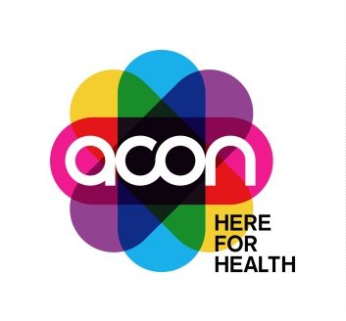

Project Officer, Cancer Program

- Full time position (35 hours per week) 3-year contract in a great location in Surry Hills Sydney
- Unique opportunity to make a significant contribution to the health of LGBTQ+ people in NSW and provide leadership in this area of health
- Join a small passionate team in an organisation well respected and engaged by the LGBTQ+ community

The Role
This is potentially the only position of its kind in Australia; a unique opportunity to combine your skills and experience of cancer control with your connection with the LGBTQ community to support ACON’s cancer screening and prevention programs. We’re looking for a health promotion or health education professional who has proven experience of successfully managing projects and is skilled at building and maintaining partnerships with stakeholders. Your ability to create and develop strong connections with target populations and a flair for social media and/or digital experience will not go unnoticed.

Cancer Program ‘Can We’
‘Can We’ is ACON’s new cancer screening and prevention brand, which encompasses all our cancer awareness, prevention and screening activities for LGBTQ communities. Our stakeholder and community relationships associated with this work are excellent, and we are well regarded for the work we do to improve health professional’s understanding, and inclusivity, of LGBTQ people in cancer programs, services and referral pathways.

The role’s responsibilities:
- With guidance, maintain partnerships with relevant funders, internal and external stakeholders to support ongoing collaboration and long-term partnerships.
- With guidance, plan, schedule, deliver and evaluate activities and outputs of ACON’s Cancer Program project(s) in line with established goals, key performance indicators and business plan objectives and funding requirements.
- In collaboration with other ACON staff, key contractors and our communities – plan, design, and implement community cancer awareness campaigns.
ACON is committed to providing our people with opportunities for professional development and growth, a safe, fun, and flexible work environment, and the scope to deliver innovative community health programs and services.
Salary: $72K-$74K (gross salary) plus superannuation and leave loading, commensurate with skills and experience.

Location:
This position is located at the ACON Sydney Surry Hills Office
This position is full time, 35 hours per week, offered on a 3-year fixed term contract.
For more information about the role, please contact Karen Price, Deputy CEO at kprice@acon.org.au or 0427 192 721.
If you think this is the job you have been looking for, find out how to apply at www.acon.org.au/jobs.
All applications must include:
- a completed ACON application form;
- a document addressing the selection criteria (max. 4 pages); and
- your resume (max. 3 pages)
Applications close 5pm Tuesday 26 April 2022.
ACON is an EEO employer. As part of our commitment to creating a diverse and inclusive workplace, people with HIV, and Aboriginal and Torres Strait Islander people are strongly encouraged to apply.
www.acon.org.au

