A GUIDE FOR APPLICANTS  ACON is Australia’s largest health organisation specialising in community health, inclusion, and HIV responses for people of diverse sexualities and genders. | 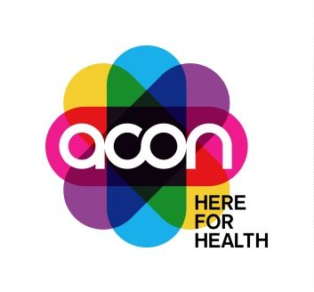

Volunteer Counsellors, LGBTQ+ Counselling Team
ACON is here for community health, inclusion and HIV responses for people of diverse sexualities and genders.
We’re looking for committed and experienced Volunteer Counsellors to join our LGBTQ Counselling Team to help us to continue providing accessible, inclusive and high-quality counselling to our communities.
- The ACON Volunteer Counselling Program was established in 2006 and has been successful in providing much needed counselling to people who are otherwise unable to access affordable counselling support
- The counselling service operates during certain weekday evenings between 5.30-8.30 pm
You’ll be joining an established team and benefit from a supportive work environment, manageable caseload, excellent clinical supervision arrangements, and opportunities for development.
This is an immensely rewarding opportunity for experienced counsellors to apply clinical expertise in a truly values led organisation.
“Working as a volunteer with ACON provided me space to develop my counselling skills and knowledge in a supportive environment. It also allowed me to connect and give back to my community in a really meaningful way. The team of volunteers I worked with made it so much fun. I always looked forward to my shifts. The experience still informs my practice today. I use the skills, knowledge and understanding of those client issues every day in my current professional role. The experience was invaluable to me” (Former volunteer)
ACON’s staff and volunteers are the foundation for our ongoing effectiveness. We are committed to our employees’ professional development and engagement. Apart from monthly group supervision, ACON will provide at least two professional development workshops each year for volunteer counsellors who actively participate in this program.
To apply, please review the Job Pack at www.acon.org.au/jobs, and submit an Expression of Interest containing the ACON Employment Application Form, a current CV and a Statement Addressing the Essential Criteria.
For further information regarding this position contact Deb Broughton, Coordinator of the LGBTQ Counselling Program on 02 9206 2000 or email dbroughton@acon.org.au.
Applications close 5pm Sunday 9 October 2022

